May 20th, 2007
Hi
Interesting reading the corresponding letter for last year, which I am overwriting. Highlights:
- This was Leonie’s last weekend in HK following her stint at POW Hospital.
- Did quite a lot of exercise for the week including 7 km swimming, which included one of 3 km.
- A typhoon, the first for the season for HK, passed by.
- The Cultural Revolution in China began this past week in 1966.
- The main dam in the Three Gorges project was completed.
- A NZ man, a double amputee, reached the summit Mt. Everest. (I think there is to be a special documentary about this in the coming week on Discovery channel.)
- The semi finals of the Super 14 were held.
This past week, I did less exercise than last year. However, now it includes skipping. I did just 110 min compared with 140 min the previous week. Also, I only managed to get two swims for the week instead of three. HK has had fine weather all week. The same was true on Friday and on checking the Observatory website just before 5 pm. there had not been a drop of rain for the whole week. So I went across to the gym to do my skipping then up to the pool for my swim. However, it was then pouring with rain and there was a thunderstorm. All within half an hou!!. So I went down to the gym again and did 25 min rowing instead, the first rowing for some time. I was happy with the time, though when I checked my diary I saw an entry for another row with the identical time as ”rather a slow row”!
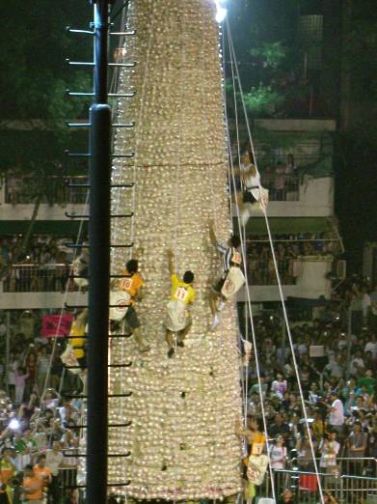

This week, the Bun festival is to be held in Cheung Chau. (The two photographs are from the 2006 festival.) However, this year they will be using plastic buns on the towers! It seems that proper buns get soggy during rain and this is dangerous for those climbing the towers. Also note in the picture that climbers now have to be fitted with climbing ropes in case they fall; not like the old days when it was a ‘free’ scramble up (and down) the towers.
I think I mentioned some time ago that NZ was not going to pass a law to ban smacking. Well, it did do this past week. So anyone who even gives a light snack is now a criminal! Apparently, NZ has a poor record for child ‘discipline’ but although it was not mentioned, I believe this is mainly among the Maori population.
Have been having some breathing problems. Took the strong prenisolone tablets for several evenings. May have to take more.
Yesterday, in Durban, South Africa, the final of the Super 14 competition was held between two SA teams with the Bulls beating the Sharks 20-19 with an injury time try to take the title. The All Black coach has been taking a bit of flak for taking the star players out of the competition for a three-month ‘conditioning’ programme in preparation for the World Cup later this year. When these players came back into the competition midway through, though ‘reconditioned,’ they were just like the other players were at the start of the season. Consequently, they did not perform so well but also suffered many injuries.
That seems to be it for now.
Cheers

